**Felon History and Change in U.S. Employment Rates**

Ryan Larson, Sarah Shannon, Aaron Sojourner & Chris Uggen

September 2019

**Abstract**

In recent decades, the share of U.S. adults with felony-level criminal records his risen and the growth in the employment rate has slowed. Sociological theories of labeling and stigmatization, as well as economic theories of statistical discrimination, suggest a possible causal connection between the two phenomena. For example, surveys of employers have shown increasing reliance on criminal background checks and audit studies reveal discrimination against people with felony-level criminal records. This paper draws on novel, state-level annual measures of individuals with felony-level records to estimate pooled cross-sectional time series models predicting changes in aggregate employment rates. Estimates suggest that a 1 percentage point increase in the share of a state’s population with a felony history is associated with 0.3 percentage point increase in non-employment (being unemployed or not in the labor force) among those age 18 to 54. Subgroup analysis shows that effects are stronger for women and whites. These results suggest that the stigma of a felony record may play an important part in aggregate employment rates as well as in individual hiring practices.

Even as the national prison population has leveled off, the population of those with a felony record outside prison… means millions of Americans have difficulty even getting their foot in the door to try to get a job, much less actually hanging onto that job. That doesn't just deprive those individuals of opportunity, it deprives businesses of talented workers, and it deprives communities in desperate need of more role models who are gainfully employed.”

* Barack Obama (2017) Harvard Law Review

**Introduction**

This paper studies the relationship between two consequential trends in America, the rise in the share of Americans with a felony record and the reversal of growth in the share of adults employed. An important legacy of the mass incarceration and probation era of U.S. punishment is the proliferation of criminal labels applied to a substantial segment of the population. In 2010, about 14.5 million Americans had a felony record but were no longer under any form of correctional supervision (that is, they were not imprisoned, on parole, nor on probation). This group constituted 6.2 percent of the U.S. adult population in 2010. Over the prior three decades, the share of American adults living in the community with a felony-record history increased by 3.8 percentage points up from 2.4 percent in 1980, a 260 percent increase (Shannon et. al. 2017). A robust literature on collateral consequences – penalties imposed above and beyond the adjudicated sentence – suggests that the proliferation of criminal records has increased the exposure of individuals to barriers in employment, housing, voting, and other areas of social life (Uggen and Stewart 2015).

Concurrent with the increase in U.S. punishment and criminal records, the U.S. employment-population ratio (EPOP) experienced slowing growth, peaking in 2000 before declining. Similar patterns describe the labor force participation rate (LFPR) and the prime-age (25-54) versions of each (U.S. Bureau of Labor Statistics). Economists have long looked to shifting demographics and business cycles to explain such changes (Aaronson et. al. 2012). Others have focused on the role of less-conventional explanations such as changes in disability-insurance policy (Liebman 2015), falling demand for the labor of those with less formal education (U.S. Council of Economic Advisers 2016), expanded trade (Autor, Dorn & Hanson 2017), automation (Acemoglu & Restrespo 2018), and the rise of opioid abuse, especially over the last decade (Krueger 2017).

Increases in punishment nationally – and the subsequent proliferation of criminal records – could play a role in suppressing employment rates nationally. A substantial research literature has explored employment outcomes for individuals with criminal records and found evidence of discrimination (e.g., Apel and Sweeten 2010; Pager 2003, 2007). Few studies to date have examined these associations at the macro level, though Looney & Turner (2018) found no evidence of an impact of incarceration on subsequent employment rates in a cross-sectional analysis of administrative records among those incarcerated in 2012. Conversely, Abraham and Kearney (2018) recently combined estimates from the literature using a novel calibration analysis to estimate the extent to which various factors explain EPOP changes. They conclude that increased incarceration rates have contributed to a statistically significant 0.13 percentage point reduction in the total employment-to-population ratio.

In this paper, we provide the first estimates of how changes in states’ share of adults with a felony record relate to changes in their aggregate employment rates. We use recently published estimates of the number of people with a felony history in each state-year, created using demographic life table methods and available annually from 1980 to 2010 (Shannon et. al. 2017). We exploit within-state variation in felony-history share over time in a generalized differences-in-differences design to generate new evidence about the causal impact of criminal records on employment rates. In doing so, we present the first estimates of aggregate-level felony records and employment, which are critical to understanding macro-level sociological and economic consequences of the criminal justice system in the U.S.

Our second contribution expands the scope of inquiry about drivers of real employment outcomes beyond the formerly-incarcerated to the broader group of those formerly convicted of a felony, whether incarcerated or not. Conviction history, not incarceration history, is the piece of information most-relevant in the job-search process and the focal factor in audit studies showing negative impacts on individuals’ chances of advancing through the process (Pager 2007; 2003). Not all people convicted of felonies are incarcerated (Shannon et al. 2017; Looney & Turner 2018). In fact, Shannon et al. (2017) estimate that in 2010 the number of U.S. adults living in the community with a felony record was three times larger than the combined number of those formerly incarcerated or on parole. The share of American adults formerly-incarcerated or on parole rose significantly between 1980 and 2010, by 1.5 percentage points, but the share with a felony history rose much more, by 3.8 percentage points. A narrow focus only on the formerly incarcerated overlooks the impact of this broader proliferation of felony records.

We first discuss the trends in both punishment and criminal records, as well as labor force participation and employment. We then review the theoretical and empirical literature on the labor market consequences of a criminal record. Following a description of the data, statistical methodology, and empirical results, we provide an extended discussion of the study’s implications for further research and public policy are explicated.

**Mass Punishment and the Rise of Criminal Records**

The United States criminal justice system has grown dramatically over the past forty years. The imprisonment rate – the number of individuals in prisons per 100,000 adults– was 161 in 1972, and peaked in 2007 at 670, and has decreased modestly to 593 at year end 2015 (Carson and Anderson 2016). The United States is an outlier internationally, compared to a world average of 144 per 100,000 (Walmsley 2015). Beyond incarceration, about 1 in 53 U.S. adults is under community supervision – probation or parole (Kaeble and Bonczar 2016) – representing a far larger correctional population pool than those incarcerated. In fact, the probation-to-incarceration ratio stood at 2.7 in 2010, a phenomenon scholars have dubbed mass probation (Phelps 2013).

This era of both mass incarceration and mass probation has led to the proliferation of felony criminal records among the U.S. population. Shannon et. al. (2017) estimate that over 19 million individuals had felony criminal convictions in 2010, which translates to about 8.1% of the overall adult population. The subpopulation of those with prison experience among those with a felony record is about 7.3 million, of which about 4.9 million have completed their time on prison and/or parole. This means that of the approximately 19 million adults with felony records, nearly 12 million have served their sentences in the community while on probation.

The rise in felony records has been disproportionate by race and varies substantially between states. Shannon and colleagues (2017) show that while the share of the total U.S. adult population with felony records is about 8 percent, the share of African American adults is about 23 percent. This rate is even higher for African American men, where one-third (33 percent) have a felony record (Shannon et al. 2017). Many factors contribute to this disparity including higher police contact for African Americans as compared to whites (Gelman et al. 2007; Brame et al. 2012; Brame et al. 2014), and a resulting greater risk of imprisonment for African American men (1 in 5, as compared to 1 in 30 for white men) (Western and Wildeman 2009; Pettit and Western 2004).

The share of adults with felony records varies from less than 5 percent in many states to more than 10 percent in Florida as of 2010. This state-level variation in punishment is correlated with multiple factors, including arrest rates, economic conditions (e.g., unemployment), demographics (e.g., African American population share), welfare expenditures, and conservative political control (Beckett 1997; Greenberg and West 2001; Jacobs and Helms 2001; Jacobs et. al. 2005; Behrens et. al. 2003; Chamlin 1989; Liska et al. 1981; Jacobs 1979; Kent and Jacobs 2004; Jacobs and O’Brien 1998; Liska and Chamlin 1984; King et. al. 2015; Myers and Talarico 1987). Criminal justice policies and processing also vary substantially by state. For example, Beckett et al. (2006) show that police surveillance and organizational practices can shape the demographic and racial pattern of imprisonment. Additionally, conviction rates (Bridges and Steen 1998) and the proportional use of prison and probation (Phelps 2017) show substantial state-by-state variation.

**Trends in Employment Rate**

The aggregate U.S. employment-to-population ratio rose from the 1960s through the 1990s, peaking in 2000. The entrance of women into the labor force, the entry of the baby boom cohort into the prime-age working years in the 1970s and 1980s, improvements in health technology, and the shift away from manual labor occupations all contributed to this rise (Aaronson et. al. 2012). Between the 2000 peak and the depths of the Great Recession in 2010,EPOP declined back to a level not seen since 1983 (Bureau of Labor Statistics 2018). The same basic pattern of deceleration and reversal of growth holds if one restricts attention to prime-age (those aged 25-54) adults only or to labor force participation rates.

Economic research has attributed this post-2000 drop to both the recession – and its lackluster recovery – and demographic trends (Aaronson et. al. 2015; Aaronson et. al. 2014). In 1996, the first baby boomer cohort turned 50, which generally represents a peak in participation. Additionally, there teen work activity has declined, due in part to increased youth involvement in educational activities in the later 2000s, as well as changes in immigration and occupational polarization (Smith 2011). Aside from these structural influences, cyclical weakness in the business cycle also depresses the participation rate (Aaronson et. al. 2014). Other research emphasizes demand side factors such as trade and the introduction of automation into the labor market, and suggests that supply side factors, such as enrollment in disability insurance programs, play a smaller role (Abraham and Kearney 2018).

A pair of studies (Schmitt and Warner 2013; Abraham and Kearney 2018) estimate that incarceration has reduced the employment-to-population-ratio from between 0.1-1.5 percentage points in recent years. Although they do not directly model this effect (each estimate is derived from estimates of the number of people with incarceration histories and a presumed effect size), it proves a baseline by which to compare our estimates of the effect of felony history population share (in which incarceration is incorporated) on state labor force participation rates. Our study takes this analysis further, examining whether state-level felony record history share is an additional explanatory factor in state variation in the not-employed rate.

**Punishment, Records, and Employment**

Two primary theoretical perspectives suggest that felony records have detrimental impacts on employment prospects. The stigma or market signal perspective suggests that the mark of criminal record serves as a tangible signal to employer – who are making hiring decisions with incomplete information – about the “kind of employee” an individual is likely to be (Apel and Sweeten 2010, p. 451), and in this way resembles statistical discrimination (Arrow 1973). Beyond fears of “employee crime,” a criminal record may spur employer assumptions about productivity, trustworthiness, social skills, and other factors that are stereotypically associated with criminal behavior. The criminal record serves as a form of discrediting social stigma (Goffman 1963) which can result in institutional exclusion from the labor force and create social disadvantages that accumulate over time (Becker 1963; Sampson and Laub 1997). In addition to structural exclusion, the labeling process may transform individual identities and behaviors that impact interaction with the labor market. Individuals labeled with a criminal record may adopt a criminal self-concept and take on the roles, attitudes, and behaviors associated with that identity (Jensen 1972; Lemert 1951; Massoglia and Uggen 2010; Matsueda and Heimer 1997). As a result, labeled individuals may place less value of legitimate employment and other societal conventions, and withdraw from the normative institution of work.

A second theoretical strain claims that contact with the criminal justice system can decrease human capital and create experience gaps, as well as undermine health and social relationships, all of which are theorized to drive potential wages and employment (Apel and Sweeten 2010; Western 2006; Massoglia 2008). For example, punishment may interrupt engagement in the labor market, eroding skills and work experience important for employment (Western, Kling, and Weiman 2001; Apel and Powell 2019). The conditions of punishment may also directly affect both physical and mental health (Schnittker, Massoglia, and Uggen 2012). Incarceration and the experience of punishment can be a stressful life event, and formerly incarcerated individuals are likely to encounter more stressors after release such as stigma and discrimination and finding housing, which in turn exposes one to illnesses associated with stress (Massoglia 2008). Finally, the label of a criminal conviction can impact the formation and stability of social networks and the resources associated with social ties. Incarceration, or stigma from a record, can distance one from key social ties that can assist in job search (Berg and Huebner 2010).

A number of studies have examined the labor market consequences of criminal justice events and outcomes (e.g., arrest) on various employment-related outcomes. Several observational studies focus on the impact of incarceration on subsequent employment using administrative data sources (Waldfogel 1994; Grogger 1995; Kling 2006; Pettit and Lyons 2007; Sabol 2007; Lalonde and Cho 2008; Loeffler 2013; Looney & Turner 2018) or survey data such as the National Longitudinal Survey of Youth 1979 (NSLY79) (Freeman 1992; Western 2002, 2006; Raphael 2007; Apel and Sweeten 2010). This focus on incarceration encapsulates the experience of only a portion of those subject to a felony conviction.

In general, survey-based studies find that incarceration is negatively associated with subsequent employment, reducing employment by about 10 to 20 percent after incarceration. Some studies examine the impacts of incarceration on wages and wage growth. For example, Western (2002) finds that imprisonment is associated with depressed wages – about 16 percent lower than those not incarcerated- and wage growth stagnation. Findings from studies using administrative datasets are less consistent, with both negative and null findings, and effect magnitudes of incarceration on employment that are smaller than the survey-based studies (e.g., about 5 percent reduction in employment likelihood). Harding et al. (2018) speculate that the discrepancy in results could be the result of differences in the “control group” since administrative datasets compare convicted groups (e.g., prison vs. parole), whereas survey studies compare those incarcerated to a more general population. Further, studies of administrative data generally find that incarceration increases employment in the short-term following release, particularly among those with a limited presentence work history, but this effect erodes over time (e.g., Harding et. al. 2018).

Another strain of scholarship uses experimental audit methodologies to examine the impact of a criminal record on employment outcomes. Such studies manipulate the signal of a criminal record on job applications and resumes, which measure the “credentialing” effect of punishment on employment prospects. For example, Pager (2003) sent testers to apply in-person for jobs in Milwaukee and manipulated the race and criminal record of the applicant. Results showed that, among white applicants, the presence of a felony record decreased the likelihood of a callback by 50 percent as compared to the control tester with no record. Further, Pager (2003) found an effect of race, such that the African American testers with no felony record were less likely to receive a job callback than their white counterparts. Overall, the felony record penalty for African American testers was 40 percent larger than that of whites.

In a follow-up study in New York City, Pager et al. (2009) used two teams of white, African American, and Latinx testers and found that whites received more callbacks than either Latinx or African American testers, and Latinx applicants were preferred over African American applicants. However, when comparing African American and Latinx testers to white applicants with a criminal record, they found no statistically significant differences in callback rates, indicating that “while ex-offenders are disadvantaged in the labor market relative to applicants with no criminal background, the stigma of a felony conviction appears to be no greater than that of minority status (p. 10).” While Pager (2003) and Pager et al. (2009) tested a criminal record with a drug possession felony, Uggen et al. (2014) examine the lower “the edge of stigma” in an audit study signaling a disorderly conduct arrest that did not lead to a conviction. They find roughly a four-percentage point difference (about 30 percent less likely) between the treatment conditions for both white and African American testers. In addition, Uggen et al. (2014) find a statistically significant effect of misdemeanor arrest on callback rates once adjusting for contact with the hiring authority, which increases the likelihood of a callback.

On balance, theoretical and empirical scholarship suggest that the proliferation of criminal records should depress labor force participation at the aggregate-level. A negative effect of felony records on employment rates would be in line with prior research demonstrating the stigmatizing effects of a criminal record. Conversely, a null or positive effect could indicate that compensating factors, such as work requirements tied to probation or parole status, offset the anticipated negative effects. Similarly, the population with felony convictions may already have such precarious labor force attachments that the felony label has a negligible impact in the aggregate.

When it comes to particular subgroups, audit studies show that the stigma of a criminal record takes a heavy toll on African American job applicants (Pager 2003, 2007; Pager et al. 2009; Uggen et al. 2014). Moreover, African American men, in particular, have higher levels of felony conviction than other subgroups (Shannon et al. 2017). As of 2010, an estimated one-third of adult African American men (and nearly one-quarter of all African American adults) had a felony conviction, as compared to eight percent of the U.S. population as a whole. This clear difference in *levels* of felony conviction among African Americans suggests that this subgroup would experience more detrimental labor force outcomes than other groups as a result of stigma.

Differences in *effects* between subgroups are less clear, however. Recent research on “ban the box” policy implementation has found unanticipated effects for minority men, such that in the absence of the box, employers appear to draw on stereotypical assumptions about demographic characteristics and criminal records (Doleac and Hansen 2016). Employers exaggerate racial differences in felony conviction rates, such that young men of color are presumed to have a criminal record unless proven otherwise (Agan and Starr 2017; Doleac and Hansen 2016). Such discrimination may mean that African American men are already so stigmatized in the labor market that increasing felony history rates for this demographic may have no discernable effect on aggregate employment rates. More advantaged subgroups, such as whites and women, however, may experience stronger labeling effects precisely because the felon label is more often associated in employers’ minds with minority men (Chiricos, Barrick, and Bales 2007). In this sense, subgroups with lower *levels* of felony conviction may experience greater negative *effects* in the labor market since the felon label contradicts stereotypes that employers may typically rely on in making hiring decisions.

In the analysis that follows, we use a generalized differences-in-differences design on a state-level pooled cross-sectional data set that relates changes in states’ not-employed-rate (*Yst*) over time to their change in share of adults in the community with a felony record (*Fst*). We do so for the not-employed-rate for all adults age 18-54, then for several subgroups by race and sex to determine whether and for which groups the rise in felony records has impacted labor force participation rates in the United States.

**Data and Design**

Our predictor of primary interest is the share of the state-year adult (18+) population living in the community with a felony record but no longer under supervision. More specifically, we used Shannon et al.’s (2017) annual state-level estimates generated using demographic life table methods. These estimates were calculated by taking the annual cohort of prison releases and felony probation entries from each year from 1948 to 2010 and adjusting for mortality, recidivism, mobility, and deportation. Each release cohort is adjusted in the same way each subsequent year, and summed with each new cohort of releases.[1] These annual state-level estimates of the population with a felony label offer a more-comprehensive view of the reach of the criminal justice system that other estimates, as they encapsulate more than just one stage or event of the criminal justice process (e.g., arrest). The estimates include both those with prison experience (e.g., Pettit 2012) and those who have not served prison time but may still suffer labor-market consequences of a felony record. The variable excludes those currently under correctional supervision. On average across our sample of state-years, about 4.3 percent of adults have a felony history, with a standard deviation of 1.7 percentage points, a minimum of 1.2 percent and a maximum of 12.3 percent (Table 1).

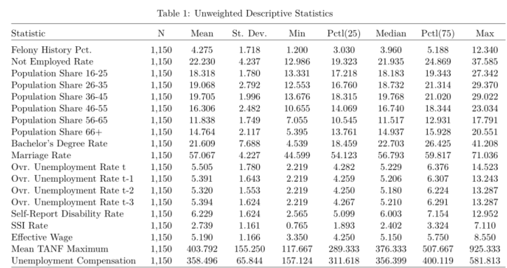

Figure 1 displays the spatial distribution of felony history rates in 2010 as a percentage of the adult population with a felony record. States such as Georgia and Florida stand out with percentages above 10 percent, and the Northeast U.S. is marked by relatively low percentages (2-3 percent) of individuals with felony records.

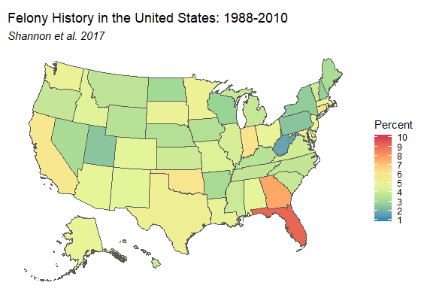

In addition to the spatial variation depicted in Figure 1, felony history shares have changed over time at divergent rates across the states. Figure 2 presents both state and time variation in state-level felony history share. Each line represents an individual state’s felony history share. Though all states demonstrate upward trajectories over the period, the rates of growth and timing of changes vary substantially. For example, Georgia, has one of the steepest growth trajectories, whereas Minnesota has experienced a flatter increase in felony history share.

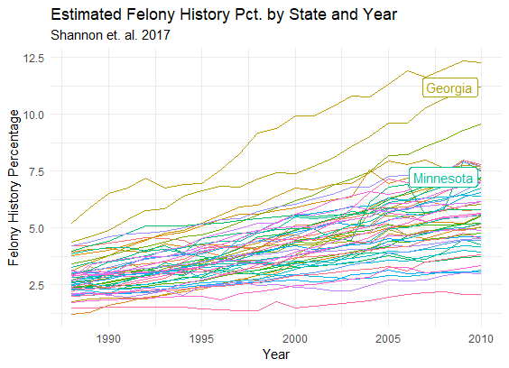

Our primary outcome variable is the not-employed-rate for age 18-54 civilian, non-institutionalized adults in each state and year, calculated from the Current Population Survey (CPS) micro-data. [2] Importantly, this measure excludes currently incarcerated individuals (who are also excluded from our key predictor variable). We conduct our analysis at the state-year level across the 50 states from 1988 to 2010. The not-employed rate (NER) is the complement to the employment-to-population ratio and equals the share of people either unemployed or not in the labor force. We use it rather than EPOP simply for ease of exposition; a rise in felony-history share is expected to cause a rise in the not-employed rate. A positive NER effect implies an equal and opposite effect on EPOP.

CPS started tracking disability status in 1988 and this is an important potential predictor of non-employment (Autor & Duggan 2003; Maestas, Mullen & Strand 2013; Austin, Glaeser & Summers 2018), so we start our analysis in this year. However, to take full advantage of the Shannon et al. (2017) estimates back to 1980, we present additional models that include the full set of years and model disability in alternative ways. Figure 3 displays the spatial distribution of the not-employed rate averaged across years 1988 to 2010. The upper Midwest is characterized by lower NER levels, as compared to states in the southern U.S. A few states, such as West Virginia and Louisiana, stand out as having particularly high NER levels. The average not-employed-rate across state-years in our sample is 22.2 percent, with a standard deviation of 4.2 percent, minimum of 13.0 percent and maximum of 37.6 percent.

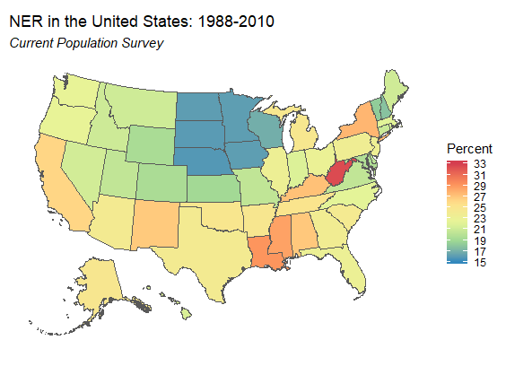

Figure 4 displays the spatial and time variation present in U.S. NER across our time series. Most states follow a general decrease throughout the 1990s with a short bump upwards in the early 1990s. This is followed by a general increase until the mid-2010s, with a sharp increase and decrease in the early 2000s. This upward trend toward the late 2000s matches with that of state-level felony history share (see Figure 4). These outcomes are driven by the business cycle and many other factors, potentially including felony-history share.

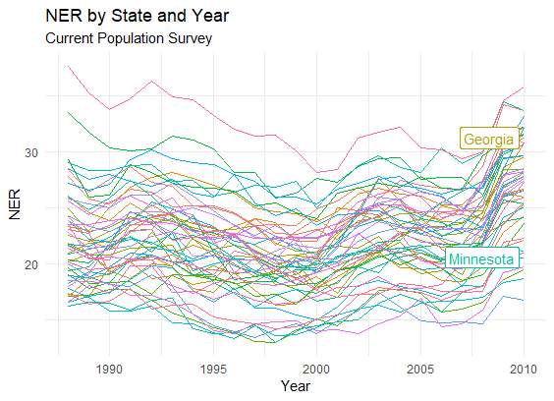

To obtain an estimate of the effects of felony history on non-employment, we use a generalized differences-in-differences design that relates changes in states’ not-employed-rate (*Yst*) over time to their change in share of adults in the community with a felony record (*Fst*). Conventional difference-in-difference estimates measure a treatment and control group at two different points in time, and compare the difference in outcome levels accounting for the baseline differences in the outcome variable. However, our treatment is applied as a dosage as opposed to a binary indicator, and our data includes multiple time periods. We include state fixed effects ($γ_{s}$) to capture average, time-stable, unobserved influences on each state’s outcome and year fixed effects ($γ_{t}$) to capture average unobserved influences common across states within each year, such as macroeconomic or national policy changes:

$$Y_{st}= βF_{st}+αX_{st}+γ_{s}+γ_{t}+ε_{st}$$

The identifying assumption is that changes in unobserved influences within state are mean independent of changes in state felony history share. All models are weighted by the total population in each state-year. We cluster standard errors by state and year to account for heteroscedasticity, autocorrelation of errors within state, and spatial autocorrelation across states within years.

**Results**

Estimating a specification with only state and year fixed effects but no observable controls yields an estimated effect of felony-history share of 0.319 (SE=0.154, p<0.05), indicating that a one percentage point increase in a state’s felony-history share increases the not-employed-rate by an average of 0.319 percentage point (Table 2: Specification 1). However, this estimate is vulnerable to omitted-variable bias from unobserved influences on the not-employed rate are correlated with changes in felony-history share. In order to enhance the credibility of the identifying condition, we add controls for three sets of observable, time-varying state-year characteristics (*Xst*) commonly used to explain labor force participation (Aaronson et. al. 2014): demographic, business cycle, and policy changes.

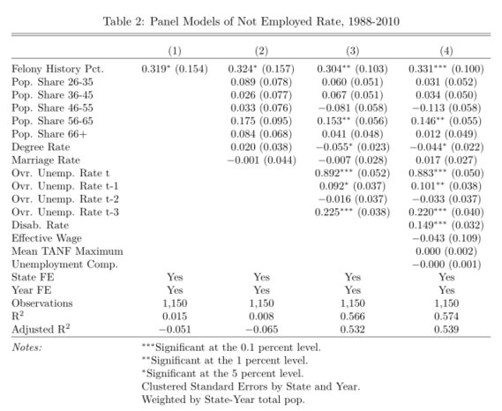

In our second specification, we condition on several demographic variables: age distribution, educational attainment, and marriage rate. Changes in states’ age distributions may drive both changes in the not-employed rate and the felony-history share. To control for changes in the overall age distribution, we use the CPS to compute state-year population shares for the age 16+ population in the following bins: 16-25, 26-35, 36-45, 46-55, 56-65, and 66+ years old. These shares sum to 100 in each state-year (Table 1) and the youngest bin share serves as the omitted group in regression analysis.

Education level and marital status also drive employment probability and may be confounded with felony history. Education level affects wages and the returns to employment. It may also be confounded with felony-history share because common characteristics may drive both education levels and propensities to be convicted of a felony. Additionally, marital status can influence labor supply incentives directly and may be confounded with felony history because it affects one’s desirability to potential spouses. To control for these influences, we measured the percentage of the population with a bachelor’s degree and the married share in the same CPS sample used to measure the not-employed-rate outcome in each state-year.

After adding these demographic controls to the model, the estimated effect of felony-history share remains quite stable at 0.324 (SE=0.157, p<0.05). The demographic controls do not have statistically significant independent effects on the not-employed-rate.

Next, to capture fluctuations in states’ business cycles, we add the overall unemployment rate in each state-year as well as three lags (t-1, t-2, t-3). This follows Aaronson et al. (2014) use of three lags of unemployment in modelling the relationship between business cycle and labor-force participation. We modify their approach slightly by also including the contemporaneous unemployment rate. Aaronson et al. (2014) could not do so because the labor-force participation outcome they use includes the unemployed, along with the employed. Our focus on the not-employed allows us to more flexibly control for business cycle. The mean unemployment rate over the study period is 5.5 percent with a standard deviation 1.8 percent. Adding these controls for business cycle in specification 3 improves model fit substantially and the estimated effect of felony-history share on the not-employed-rate attenuates only slightly and becomes more precise at 0.304 (SE= 0.103, p<0.01).

In our final specification (Specification 4), we account for alternative explanations of supply-side labor dynamics beyond felony-history share by including measures of social welfare safety net and labor policies. Factors that potentially affect employment at the low-wage end of labor markets are particularly important to include. First, changes in disability rates and policy affect employment to some extent (Autor & Duggan 2003; Maestes, Mullen & Strand 2013; Benjamin, Glaeser & Summers 2018; Abraham & Kearney 2018). The share of people claiming disability insurance rises with the unemployment rate, as it can provide a way for marginally-qualified individuals to earn income outside employment (Maestes, Mullen & Strand 2015). To control for changes in disability, we measure the self-reported disability rate among the individuals used to construct the not-employed rate outcome for each state-year. We also will present analysis assessing sensitivity of our result to using the share of adults on a disability-insurance program, rather than the share reporting a disability in the CPS survey. The mean disability rate is 6.2 percent with standard deviation 1.6 percent, minimum 2.6 percent and maximum 13.0 percent (Table 1).

Second, we control for the real value of the effective minimum wage, which equals the maximum of the state minimum wage and the federal minimum wage in each state-year. This averages $5.19 per hour with a standard deviation of $1.17 over the study period. Third, we control for changes in states’ welfare programs using the mean Assistance to Families with Dependent Children or Temporary Assistance to Needy Families maximum benefit amount for a 2-person family, a 3-person family, and a 4-person family in each state-year. This averages $403 over the study period. Both the effective minimum wage and AFCD/TANF data come from the University of Kentucky’s Center for Poverty Research Welfare Data. Finally, we include a control for the generosity of the state’s unemployment compensation system with the maximum weekly unemployment benefit by state-year from Michigan State University’s Correlates of State Policy dataset, which averages $358 during the study period.

Adding controls for social welfare and labor policy yields a similar estimate of the felony-history share effect, at 0.331 (SE=0.100, p<0.001), as reported in Specification 4 of Table 2. For comparison, the estimated effect of the same increase in disability share is about half as large, 0.149 (SE=0.032, p<0.001).

**Robustness**

Table 3 presents models focused on alternative subgroup samples using the richest specification from the main analysis (Table 2: Specification 4). Specifically, we model the effect of felony history share separately for male and female not-employed rates, and separately for white and African American not-employed rates. Shannon et. al. (2017) provide two state-level estimates: an overall felony history percentage and a African American felony history percentage for African Americans. Therefore, we utilize the African American specific measure of felony-history share in our African American model for that subgroup, but use the overall rate in each of the other models. Due to data limitations, Shannon et. al. (2017) were unable to generate state-level estimates of the felony history share by sex. Where applicable, CPS-based control variables were computed for the specific subgroups. However, other control variables (e.g., mean TANF max) apply equally across the groups.

As shown in Table 3, felony history percentage has a nonsignificant, albeit positive, impact on the not-employment-rate for men (Table 3: Specification 1). In contrast, among women, felony-history share shows a statistically significant effect on non-employment almost 5 times larger than that of the male subgroup. A similar bifurcation appears in the race submodels. A statistically significant effect exists for the whites but not African Americans.[3] In both cases, the felony-history effect is larger in the group with a lower felony-history base rate.

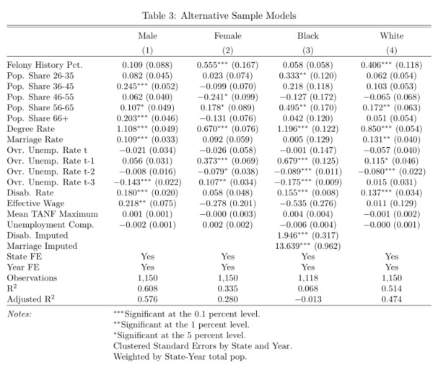

Because the CPS measure of disability is not available until 1988, we explore how several alternative specifications of disability that are available earlier in the growth of incarceration rates affect the estimate of felony-history share in Table 4. Specification 1 adds the SSI recipient rate from administrative case data in addition of the self-reported disability rate from the CPS. The SSI rate has a lower mean and standard deviation than self-reported disability (Table 1). This model maintains the same time period as Table 2 (1988-2010), to see how measurement alone changes the felony-history share effect estimate. Specification 2 adds in years 1980 to 1987, before the CPS collected self-reported disability, in order to exploit all available years of felony-history share using an imputed self-report disability rate in the 1980-1987 series (see footnote 2). Model 3 keeps the imputation and the additional years but removes the SSI rate from the specification. Across all three alternative models, felony history percentage maintains its statistically significant positive effect with a magnitude just above .3 in all models.

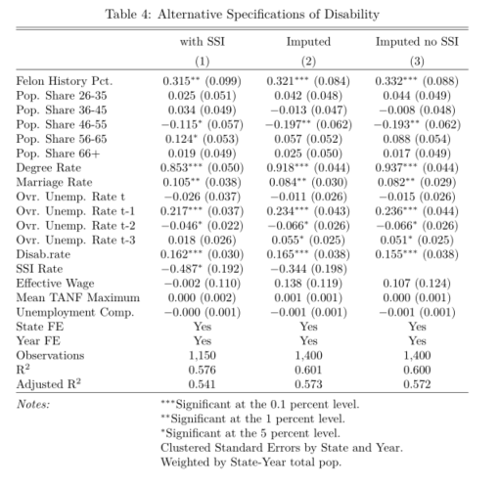

**Discussion**

Combining the observed change in states’ average felony-history share (3.1 percentage points) between 1988 and 2010 and our 0.33 estimate of the felony-history share effect yields an estimate that this factor accounts for a 1.0 percentage point rise in the not-employed rate among Americans aged 16 to 54 or, equivalently, a 1.0 percentage point fall in their employment-to-population ratio. In contrast, our estimates imply that the observed 1.0 percentage point increase in the disability rate across the same period accounts for a 0.15 percentage point rise in the not-employed rate. The change in felony-history share has more than 6 times as much impact as the change in the disability rate.

At first glance, our estimate that the rise in felony-histories reduced EPOP by 1.0 percentage point appears inconsistent with Abraham and Kearney’s estimate that the rise in incarceration reduced it by only 0.13 percentage points. However, three big differences between our analyses – the time period, the treatment, and the outcome – explain most of this apparent difference. First, we study 1988 to 2010 and they study 1999 to 2016. During the period of overlap, 1999 to 2010, felony-history share rose by 1.7 percentage points. Projecting this forward linearly another 6 years would imply a total rise of 2.6 percentage points over their period of study and, with our 0.33 effect estimate, would imply a 0.86 reduction rather than a 1.0 percentage point one. Second, we study the effect of felony-history share while they focus on incarceration-history share. Felony-history share is about three times larger than incarceration-history share and rises about three times as much between 2000 and 2010 (Shannon et al. 2017). So, a third of a 0.86 reduction is a 0.29 reduction. Finally, we look among adults up to age 54 and they look at all adults. The former systematically have higher EPOP than the latter, so effects will tend to be larger. Their 1999 age-specific EPOP and population shares imply that the EPOP of the latter is 84 percent that of the latter. Scaling down the 0.29 effect by this ratio yields an estimate of 0.24. This is still almost double the Abraham and Kearney estimate but far reduced from 6.6 times larger. However, the simple fact that the felony-history population is three times larger and grew three times as fast as the incarceration-history population suggests that the rise of felony convictions more broadly may have much bigger impacts on the labor market than incarceration-only estimates imply.

Our examination of the effect of felony history share on specific subgroups yielded some surprising effects by race and sex. Given the well-documented disparities in felony history share by race, with African American state populations more heavily burdened by this marker (Shannon et al. 2017), and audit studies showing greater discrimination against African American men with criminal records in hiring decisions, we would have expected a significant effect of state-level felony history share on African American EPOP. Instead, our models in Table 3 show a non-significant effect of African American felony history share on African American EPOP but a significant effect on EPOP for Whites. Further, given that males make up the vast majority of people with felony records, we would have expected a significant effect of state-level felony history share on male EPOP. Yet, instead we see a non-significant association for males but a significant effect for females.

The reason for these surprising results is not entirely clear, but some prior research suggests that populations that are generally more privileged may experience more pronounced stigma in the presence of a discrediting marker. For example, criminological research has shown that women may be more adversely affected by a label like a felony conviction given cultural expectations around women as more nurturing and concerned for interpersonal relationships than men (Chiricos et al. 2007). The felony label might then stand out as more aberrant to prospective employers for women as compared to men (Girodano, Cernkovich, and Lowery 2004). The same could be true for whites, in general, given employers’ stereotypical assumptions about criminality and racial minorities. Our models might be showing that, while individuals who are racial minorities may certainly experience stigma due to criminal records in hiring (as shown by audit studies), at the aggregate level these effects are washed out by the overriding stigma of race. Instead, what we detect at the macro-level is an enhanced stigmatizing effect for those populations for whom a felony conviction contradicts stereotypical assumptions about criminality. Because women and whites are less strongly associated with criminality in the minds of employers, they have “farther to fall” when the felony label is applied than do men or racial minorities. Our results certainly point to the need for further research on this point.

**References**

Aaronson, Daniel, Jonathan Davis, and Luojia Hu. 2012. “Explaining the Decline in the U.S. Labor Force Participation Rate.” *Chicago Fed Letter*, Federal Reserve Bank of Chicago, March.

Abraham, Katharine G. and Melissa S. Kearney. 2018. “Explaining the Decline in the U.S. Employment-to-Population Ratio: A Review of the Evidence” (February 2018). NBER Working Paper No. w24333.

Acemoglu, Daron, and Pascual Restrepo. 2018. "The Race between Man and Machine: Implications of Technology for Growth, Factor Shares, and Employment." *American Economic Review*, 108 (6): 1488-1542.

Amanda Agan, Sonja Starr. 2017. “Ban the Box, Criminal Records, and Racial Discrimination: A Field Experiment.” *The Quarterly Journal of Economics* 133:191–235.

Apel, Robert, and Kathleen Powell. 2019. “Level of Criminal Justice Contact and Early Adult Wage Inequality.” *RSF: The Russell Sage Foundation Journal of the Social Sciences* 5: 198–222.

Apel, Robert, and Gary Sweeten. 2010. The impact of incarceration on employment during the transition to adulthood. So*cial Problems* 57:448–79.

Arrow, Kenneth J. 1973. “The theory of discrimination.” In *Discrimination in Labor Markets,* eds. Orley Ashenfelter and Albert Rees. Princeton, NJ: Princeton University Press.

Austin, Benjamin, Edward Glaeser, and Lawrence H. Summers. "Saving the heartland: Place-based policies in 21st century America." *Brookings Papers on Economic Activity Conference Drafts*. 2018.

Autor, David H., David Dorn and Gordon H. Hanson. 2017. “When Work Disappears: Manufacturing Decline and the Falling Marriage-Market Value of Men.” Working Paper, University of Zurich.

Autor, David H., and Mark G. Duggan. "The rise in the disability rolls and the decline in unemployment." *The Quarterly Journal of Economics* 118.1 (2003): 157-206.

Beckett, Katherine. 1997. *Making Crime Pay: Law and Order in Contemporary American Politics.*  Oxford University Press.

Beckett, Katherine, Kris Nyrop and Lori Pfingst. 2006. “Race, Drugs and Policing: Understanding Disparities in Drug Delivery Arrests.” *Criminology* 44:105-138.

Berg, Mark T., and Beth M. Huebner. 2011. “Reentry and the Ties that Bind: An Examination of Social Ties, Employment, and Recidivism.” *Justice Quarterly* 28:382-410,

Brame, Robert, Shawn D. Bushway, Ray Paternoster, and Michael G. Turner. 2014. “Demographic patterns of cumulative arrest prevalence by ages 18 and 23.” *Crime & Delinquency* 60:471-486.

Brame, Robert, Michael G. Turner, Raymond Paternoster, and Shawn D. Bushway. 2012. “Cumulative prevalence of arrest from ages 8-23 in a national sample.” *Pediatrics* 129:21-27.

Bridges, George S., and Sara Steen. 1998. “Racial disparities in official assessments of juvenile offenders: Attributional stereotypes as mediating mechanisms.” *American Sociological Review* 63: 554-570.

Carson, Ann E., and Elizabeth Anderson. 2016. *Prisoners in 2015*. Washington, DC: U.S. Department of Justice, Office of Justice Programs, Bureau of Justice Statistics.

Chiricos, Ted, Kelle Barrick, William Bales, and Stephanie Bontrager. 2007. “The labeling of convicted felons and its consequences for recidivism.” *Criminology* 45:547-581.

Doleac, Jennifer L. and Hansen, Benjamin. 2018. “The Unintended Consequences of 'Ban the Box': Statistical Discrimination and Employment Outcomes When Criminal Histories Are Hidden.” Available at SSRN: https://ssrn.com/abstract=2812811 or http://dx.doi.org/10.2139/ssrn.2812811

Freeman, Richard B. 1992. “Crime and the employment of disadvantaged youths.” In G. Peterson and W. Vroman (Eds.), *Urban Labor Markets and Job Opportunities*. Washington, DC: Urban Institute Press.

Gelman, Andrew, Jeffrey Fagan, and Alex Kiss. 2007. “An analysis of the New York City Police Department’s “Stop-and-Frisk” policy in the context of claims of racial bias.” *Journal of the American Statistical Association* 102: 813-823.

Goffman, Erving. 1963. *Stigma: Notes on the Management of Spoiled Identity*. Englewood Cliffs, NJ: Prentice-Hall.

Grogger, Jeff. 1995. “The effect of arrest on the employment and earnings of young men.” *Quarterly Journal of Economics* 110:51-72.

Greenberg, David F. and Valerie West. 2001. “State Prison Populations and Their Growth, 1971–1991.” *Criminology* 39:615–54.

Harding, David J., Jeffrey D. Morenoff, Anh P. Nguyen, and Shawn D. Bushway. 2018. "Imprisonment and Labor Market Outcomes: Evidence from a Natural Experiment." *American Journal of Sociology*124 (2).

Jacobs, David, Jason T. Carmichael, and, Stephanie L. Kent. 2005. "Vigilantism, Current Racial Threat, and Death Sentences." *American Sociological Review* 70:656-677.

Jacobs, David and Ronald E. Helms. 1996. “Toward a Political Model of Incarceration: A Time-Series Examination of Multiple Explanations for Prison Admission Rates.” *American Journal of Sociology* 102:323–57.

Jacobs, David and Robert M. O'Brien. 1998. "The Determinants of Deadly Force: A Structural Analysis of Police Violence." *American Journal of Sociology* 103:837-62.

Jensen, Gary. 1972. “Delinquency and adolescent self-conceptions: a study of the personal relevance of infraction.” *Social Problems* 20:84-103.

Kaeble, Danielle, and Thomas P. Bonczar. 2016. *Probation and Parole in the United States, 2015*. Washington, DC: U.S. Department of Justice, Office of Justice Programs, Bureau of Justice Statistics.

Kent, Stephanie L. and David Jacobs. 2004. “Social Divisions and Coercive Control in Advanced Societies: Law Enforcement Strength in Eleven Nations from 1975 to 1994.” *Social Problems* 51: 343-361.

Kling, Jeffrey R. 2006. “Incarceration length, employment and earnings.” *American Economic Review* 96:863-876.

Krueger, Alan. 2017. “Where Have All the Workers Gone? An Inquiry into the Decline of the U.S. Labor Force Participation Rate.” Conference draft. Washington, DC: Brookings Institution.

Lalonde, Robert J., and Rosa M. Cho. 2008. “The impact of incarceration in state prison on the employment prospects of women.” *Journal of Quantitative Criminology* 24:243-265.

Lemert, Edwin M. 1951. *Social Pathology: Systematic Approaches to the Study of Sociopathic Behavior*. New York: McGraw-Hill.

Liebman, Jeffrey. 2015. “Understanding the Increase in Disability Insurance Benefit Receipt in the United States.” *Journal of Economic Perspectives* 29: 123–50.

Liska, Allen E. and Mitchell B. Chamlin. 1984. “Social Structure and Crime Control Among Macrosocial Units.” *American Journal of Sociology* 90:383-95.

Loeffler, Charles E. 2013. “Does imprisonment alter the life course? Evidence on crime and employment from a natural experiment.” *Criminology* 51:137-166.

Looney, Adam, and Nicholas Turner. 2018. *Work and Opportunity Before and After Incarceration* (Economic Studies at Brookings). Brookings Institution.

Maestas, Nicole, Kathleen J. Mullen, and Alexander Strand. 2013. "Does disability insurance receipt discourage work? Using examiner assignment to estimate causal effects of SSDI receipt." *American economic review* 103.5: 1797-1829.

Maestas, Nicole, Kathleen J. Mullen, and Alexander Strand. 2015. "Disability insurance and the great recession." *American Economic Review* 105.5: 177-82.

Massoglia, Michael. 2008. “Incarceration as Exposure: The Prison, Infectious Disease, and Racial Disparities in Health. *Law & Society Review* 42: 270-306.

Massoglia, Michael and Christopher Uggen. 2010. “Settling Down and Aging Out: Toward an Interactionist Theory of Desistance and the Transition to Adulthood.” *American Journal of Sociology* 116:543-582.

Matsueda, Ross L., and Karen Heimer. 1997. “A Symbolic-Interactionist Theory of Role-Transitions, Role-Commitments, and Delinquency.” Pp. 163–213 in *Developmental Theories of Crime and Delinquency, Advances in Criminological Theory, vol. 7*. Edited by Terence Thornberry. New Brunswick, N.J.: Transaction.

Myers, Martha and Suzette Talarico. 1987. *The Social Contexts of Criminal Sentencing*. New York: Springer-Verlag.

Pager, Devah. 2003. “The mark of a criminal record.” *American Journal of Sociology* 108:937–75.

Pager, Devah. 2007. *Marked: Race, Crime, and Finding Work in an Era of Mass Incarceration*. Chicago, IL: University of Chicago Press.

Pettit, Becky. 2012*. Invisible Men: Mass Incarceration and the Myth of Black Progress.* New York: Russell Sage Foundation.

Pettit, Becky, and Christopher Lyons. 2007. “Status and the stigma of incarceration: The labor market effects of incarceration by race, class, and criminal involvement.” In D. Weiman, S. Bushway, and M. Stoll (Eds.), *Barriers to Re-entry: The Impact of Incarceration on Labor Market Outcomes* (pp. 203-226). New York: Russell Sage Foundation.

Pettit, Becky, and Bruce Western. 2004. “Mass Imprisonment and the Life Course: Race and Class Inequality in U.S. Incarceration.” *American Sociological Review* 69:151–69.

Phelps, Michelle S. 2017. “Mass probation: Toward a more robust theory of state variation in punishment.” *Punishment & Society* 19:53–73.

Raphael, Stephen. 2007. “Boosting the earnings and employment of low-skilled workers in the United States: Making work pay and reducing barriers to employment and social mobility.’ In T.J. Bartik and S.M. Houseman (Eds.), *A Future of Good Jobs? America’s Challenge in the Global Economy* (pp. 245-305). Kalamazoo, MI: W.E. Upjohn Institute.

Sabol, William. 2007. “Local labor-market conditions and post-prison employment experiences of offenders released from Ohio state prisons.” In S. Bushway, M.A. Stoll, and D.F. Weiman (Eds.), *Barriers to Reentry? The Labor Market for Released Prisoners in Post-Industrial America* (Ch. 9, pp. 257-303). New York: Russell Sage Foundation

Sampson, Robert J., and John H. Laub. 1990. ‘Crime and deviance over the life course: The salience of adult social bonds.” *American Sociological Review* 55:609–27.

Schnittker, Jason, Michael Massoglia, and Christopher Uggen. 2012. “Out and Down: Incarceration and Psychiatric Disorders.” *Journal of Health and Social Behavior* 53:448- 64.

Schmitt, John, and Kris Warner. 2011. Ex‐offenders and the labor market. *WorkingUSA*, 14:87– 109.

Shannon, Sarah, Christopher Uggen, Jason Schnittker, Michael Massoglia, Melissa Thompson, and Sara Wakefield. 2017. “The Growth, Scope, and Spatial Distribution of People with Felony Records in the United States, 1948-2010.” *Demography* 54:1795-1818.

Smith, Christopher L. 2011. “Polarization, Immigration, Education: What’s Behind the Dramatic Decline in Youth Employment?” Federal Reserve Board of Governors Finance and Economics Discussion Series 2011-41.

Uggen, Christopher, and Robert Stewart. 2015. “Piling On: Collateral Consequences and Community Supervision.” *Minnesota Law Review* 99:1871-1910.

Uggen, Christopher, Mike Vuolo, Sarah Lageson, Ebony Ruhland, and Hilary Whitham. 2014. "The Edge of Stigma: An Experimental Audit of the Effects of Low-Level Criminal Records on Employment." Criminology 52:627-654

Waldfogel, Joel. 1994. “The effect of criminal conviction on income and the trust ‘reposed in the workmen.’” *The Journal of Human Resources* 29:62-81.

Walmsley, Roy. 2015. *World Prison Population List* (11th edition). London: Institute for Criminal Policy Research.

Western, Bruce. 2002. “he impact of incarceration on wage mobility and inequality.” *American Sociological Review* 67:477-498.

Western, Bruce. 2006. Punishment and Inequality in America. New York: Russell Sage Foundation.

Western, Bruce and Chrstopher Wildeman. 2009. “The Black Family and Mass Incarceration.” *Annals of the American Academy of Social and Political Science* 621:221–242.

Western, Bruce, Jeffrey R. Kling, and David F. Weiman. 2001. “The Labor Market Consequences of Incarceration.” *Crime and Delinquency* 47:410–427.

1. See Shannon et. al. 2017 for further detail of the estimation procedure.
2. An age-specific measure of felony-history share is not available due to limitations in the source data used by Shannon et al. (2017). We can construct age-specific outcome measures and do so in such a way as to focus on the age-range most likely to have variation in felony-share history. People are much more likely to get their first felony conviction when they are young adults, under age 25, than when they are older. Therefore, the rapid rise in felony conviction rates starting in the mid-1980s was driven disproportionately by a rise roughly among those born in the 1960s and later, not those born in the 1950s or earlier. Looking out to the end of our study period, 2010, those born in the 1960s topped out at age 51. Labor economists conventionally consider ages 25 to 54 prime-aged for working. For these reasons, we focus the outcome on those up to age 54. Including older ages would include a population in which we would not expect much change in felony-history incidence or effect on employment. We estimated our models with various age filtering parameters, including a prime-age restriction, and results proved robust to multiple age specifications. Models are available upon request to the corresponding author.
3. The Black model includes imputations for both the disability rate and marriage rate, and includes binary predictors indicating missingness was not at random. We drop another 32 cases due to missing data on the dependent variable. The imputations performed were linear interpolations using data from the year before and the year subsequent the missing data point.